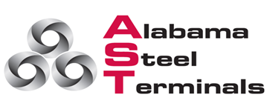
OPERATIONS FORM
VESSEL NAME:_________________ DATE OF OPERATION: ________________
STEVEDORE: __________________ CONTACT/NAME: _______________ #______________
AGENT (Company)_____________ CONTACT/NAME: _______________ #______________
**EMERGENCY CONTACT (Stevedore) : _________________________#_______________
In case of emergency, please call Mr. Tony Bryant (AST), Phone (cell) 251-331-1632
Berth/Pier Location: __________________________
Vessel Stow Plan (received): Yes ( ) No ( )**
Complete Manifest list/Bill of Lading (listing specific coil ID/PO #): Yes ( ) No ( )
** The above stow plan and manifest is mandatory and must be submitted by stevedore to AST at least 72 hrs. prior to vessel operations.

Type of Operation: DISCHARGE ( ) LOAD ( ) No. of gangs: __________
Hours:
Start up time: __________ ** Overtime __________

Operations meeting shall be required between stevedore and AST personnel prior to each vessel operation for proper planning and communication with ASPA. All communication should include ASPA GCI Manager (by email).
All working times will be confirmed (by email) between Steve Dore and AST prior to vessel operations.
**All hours applicable to overtime shall be authorized and submitted (by email) from stevedore company prior operations to AST @email: service@alsteel.us (in copy to attached contact list)

AST GOTTWALD CRANE (80 T CAPACITY) (IF NEEDED): YES ( ) NO ( ) Include crane form.

AST form agreement/signature:
Participating Stevedore Superintendent:
Signature ___________________ Date: ____________________
Alabama Steel Terminals (Manager)
Signature ____________________ Date: ____________________

